**GUIDE TO USING SIMBA**

**Getting started:**

Download the latest version from the server: <https://128.146.169.150:8443/summary/Simulation.git>

Click on the latest version, look for tree under “commit” and click on the “tree” link. Look for “Deployment Package” and click the “zip” link to download SIMBA

Once the zipped folder has been downloaded, unzip the folder by right clicking it and clicking **Extract All.**

**Running SIMBA:**

Run SIMBA.exe in the downloaded folder.

*Starting SIMBA may take a while the first time. Be patient*

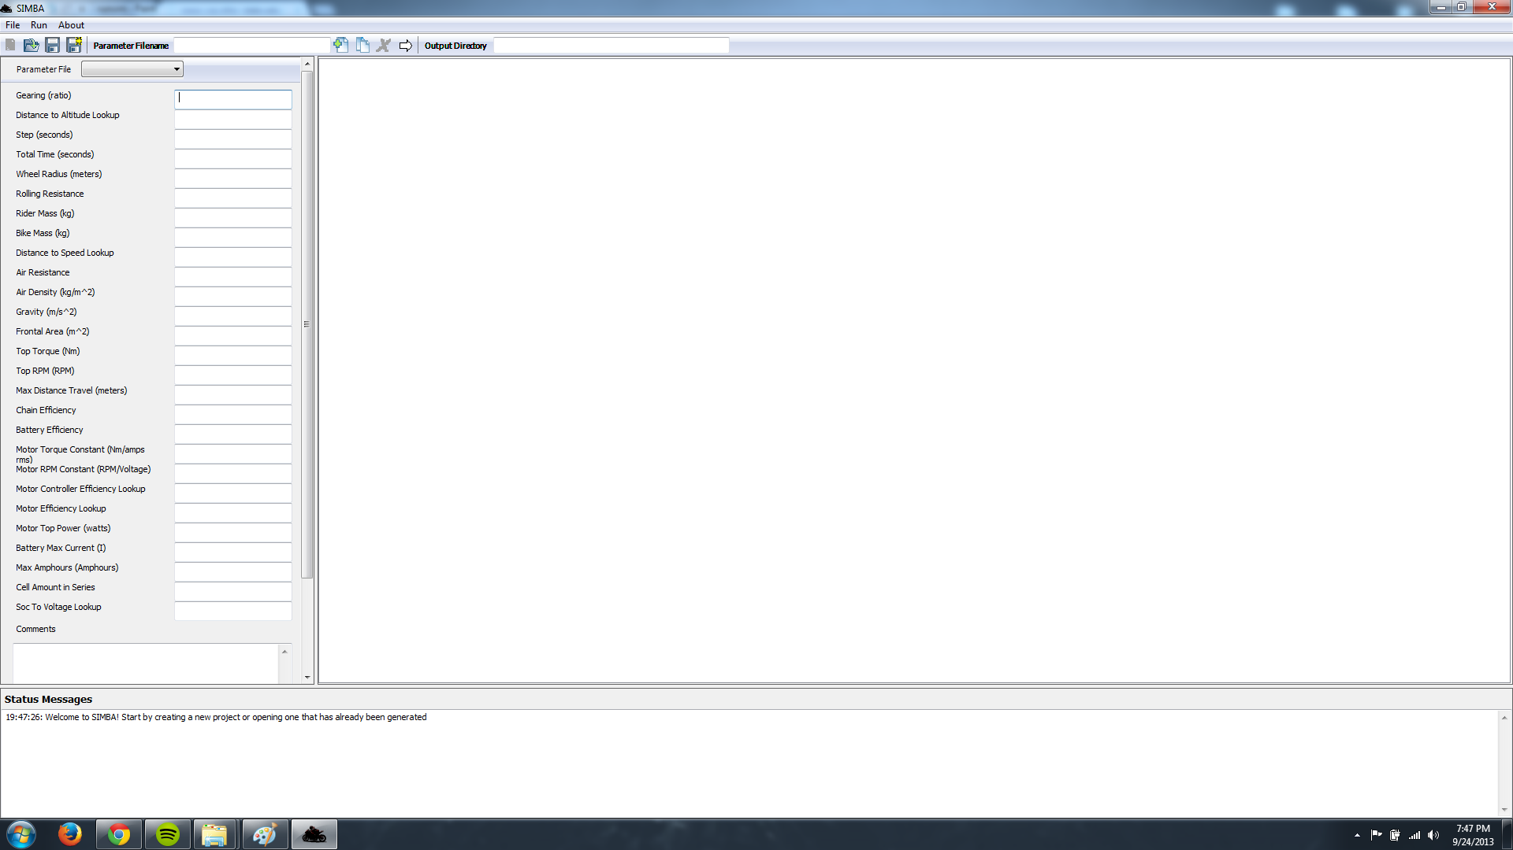

SIMBA should open after it finishes loading. There should be three main panels. The left panel is also known as the **input panel**. This is where the user will enter and change parameters. On the right, is the **output panel**. This panel shows the results from the simulation. Lastly, there is a **status panel** on the bottom which updates the users about what the program and user is doing.

**TO START:**



The image above shows the “toolbar” which essentially holds all the main tools a user will need while using SIMBA. From left to right the tools are as follows:

**New Project** (Unavailable in initial release)

**Open Project**: Opens an existing project a user has made or a template

**Save Parameter File**: Saves only the parameter file in the input panel

**Save All Parameter Files**: Saves all parameter files in the project

**Parameter Filename**: Name of new parameter file user wants to create

**New Parameter File**: Create a new parameter file with empty parameters

**Copy Parameter File**: Create a new parameter file by copying current file in input panel

**Delete Parameter File:** Delete the current parameter file in the input panel

**Run Simulation**: Run the simulation with the current parameter files in the project

**Output Directory**: Save directory of the simulation results displayed in the output panel

To get started, open the template project located in the folder you downloaded. To do this, look for the **Open Project** button in the toolbar. You can find the template project in the **test_in** folder which SIMBA.exe is located with. From there, pick one of the projects folders and then open **“OPTIONS.csv”.** The OPTIONS.csv file is the project file pointing to the files that make up the project (parameter files)

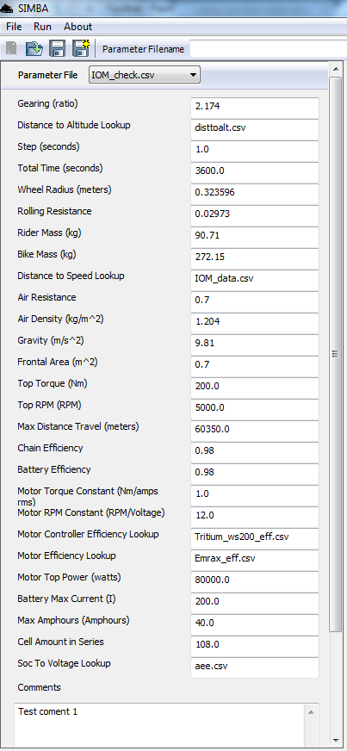

At this point, the input panel has been populated with the data in the template project parameter files. All the values of each parameter file can be edited. To change a value, simply replace it with a value of your choosing. To save changes to a parameter you have made, simply click **Save** or **Save All** in the toolbar. **Note**: Certain parameter values may cause SIMBA to downscale the value to the max value in a corresponding lookup file.

Each parameter file in a project can be found in the drop down list located just under “Open Project”. Using the picture to the left as an example, the user would click **TestTemplate.csv** to open the drop down list and select another parameter file.

The comments field in each parameter file allows the user to specify any notes they wish to incorporate with a test. The comment field will then be transferred to the output files after the simulation is ran.



**New, Copy, and Delete Parameter Files**

A new feature with SIMBA is the ability to add and remove parameters files directly from SIMBA itself. A new parameter file is an input file in a project that is ran through the simulation. The parameter files hold the data the simulation needs to run.

To add a new parameter file, there are two options: **New Parameter File** and **Copy Parameter File**. Both of these tools require a **Parameter Filename**. This is the name of the parameter file to be created. Once a filename has been entered into the **Parameter Filename** field, click either the **New Parameter File** or **Copy Parameter File** button on the toolbar.

**New:**

The **New Parameter File** will create a new blank parameter file. All of the values in this new parameter file must be populated with input except for the optional comments field.

**Copy:**

The **Copy Parameter File** will create a copy of the current file shown in the input panel. For example, if **TestTemplate.csv** is currently open in the input panel, all the values from that parameter file are then copied to the new parameter file with the name specified in **Parameter Filename**.

**Delete:**

Lastly, the user can also delete a parameter file. Clicking the **Delete Parameter File** button in the toolbar will remove the current parameter file in the input panel from the project. This will **NOT** delete the parameter file from the user’s hard drive.

**Note: The filename must end in .csv (Comma Separated Values file format). An example of a correct filename is new_test.csv. An incorrect filename is new_test.**

**Running the Simulation**

After the parameter files have the desired values, simply hit the white arrow button called **Run Simulation.** The simulation process could take anywhere from 30 seconds to 5 minutes depending on how many parameter files are in the project file you are working on. The results will then display in the right **output panel**. All the data found here can also be found in the **Output Directory** specified for the project. If you wish to save the files somewhere else, you can change the field to where you want the parameters output files to be saved. **WARNING:** Do not set the **Output Directory** to the same directory the input files are located in. Doing so will overwrite your input parameter files.

By default the **Output Directory** will be the in the **test_in** folder of the project folder.

**TO CREATE A NEW PROJECT:**

Copy and Paste the “Project Template” folder to the project location you want. The new folder can be renamed to anything you want. The OPTIONS.csv folder inside however must remain the same name. Opening the project is the same as before.